Muhammad Ruman Rashid

**Email:** [ruman.rashid@yahoo.com](mailto:ruman.rashid@yahoo.com)

**Cell#**: +**923337783677**

**DOB :08 July, 1992**

**Current Address: Shahdara Lahore,Pakistan**

**Sr. Manager Business Development**

* With over 9 Years of Experience in Sales & customer relationship
* Experience in selling off plan & high-rise real estate projects selling
* Skilled in Marketing Management, Business development, sales force management, Customer Support, Customer Service, and Complaint Management.
* Strong support professional with a Master’s in Business Administration & Bachelor's Degree focused in Business, Administration & Management, employee relation, human resources and Related Support Services from Superior University.
* Business development & establishment by identifying new business opportunities and market search.
* Ability to train, motivate & develop teams to achieve sale target through integrated competency-based management.
* Goal oriented administrator, cross functional and keen on improving efficiencies in operational processes

**AREAS OF EXPERTISE**

|  |  |  |
| --- | --- | --- |
| * Relationship Building | * Negotiation & Persuasion skills | * Business Development Management |
| * Sales Force Management | * Business Intelligence | * Corporate Communication |
| * B2C & B2B communication | * Collaboration Skills & Project Management | * Research & Strategy. |

**KEY STRENGTHS & SKILLS:**

# Communication: Presentation of ideas to various levels of audience using a comprehensive range of communications skills.

# Marketing: Conceiving, planning and implementing marketing principles to improve business performance.

# Leadership: Able to manage sales teams and ensuring all work is completed to fixed deadlines.

# Teamwork: Able to relate to individuals and form relationships quickly whilst also able to work on own initiative.

* **I.T**: Competent user of Windows: Microsoft Word, Excel, and PowerPoint.

**PROFESSIONAL EXPERIENCE**

 **Ibraya Group**

Autograph Signature Suites

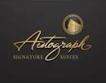 **Sr. Manager Project Sales**

May 2023 till Date

* Sales Team Management:
* Sales Strategy Development:
* Sales Process Oversight:
* Financial Management:
* Compliance and Legal:

• Establishing, maintaining and expanding the company’s client base while fulfilling the needs of existing clients’ business needs;   
• Developing /implementing sales strategies and conducting analyses of sales activities against set goals by compiling  
• Analysing sales figures; assisting in developing a long-term, sustainable business model by fostering long-term strategic partnerships with clients through superior customer services;  
• Supporting the team in achieving targets by analysing market, sales and customer-buying trends.  
• Responsible for cultivating increased business opportunities through various routes to market,  
• Ensuring that all ‘soft’ KPIs (calls and meetings) of the team are met,  
• Meeting the revenue targets assigned on a monthly/quarterly/annual basis,  
• Discovering new customer leads by identifying new markets and customer segments, and managing/coaching the assigned team



**Apex Group ®**

(Realtor, Developer, construction, Media & Marketing)

**Sr. Manager Business Development**

Jan 2023 Apr 2023

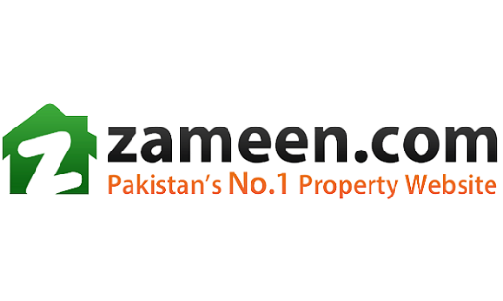

**Zameen.com**

(Pakistan’s No. 1 Real Estate company)

**Business Development Manager**

Sep 2019 to Dec 2022

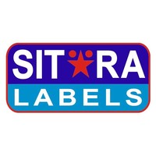

**Sitara Labels Pvt Ltd**

(Manufacturer of woven Labels )

**Marketing & Sales executive**

May 2017 to Feb 2019

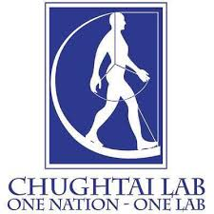**CHUGHTAI LAB**

(Laboratory/Medical Centre/Pharmacy)

Lahore, Pakistan

**Customer Relation Officer**

Apr 2016 - May 2017

**Pakistan Telecommunication Co Ltd**

**Customer Support Executive**

Sep 2014 to Oct 2015

____________________________________________________________________________________

#### EDUCATION

**Master In Business Administration**

(Management, Marketing, General)

Superior University Lahore

2018-2020

**_________________________________________________________**

**Bachelor in Business Administration (Honours)**

(Marketing)

Superior University Lahore

2010-2014